Industrial A5S Sensor with Modbus RTU/MQTT Communication

1. Product Overview
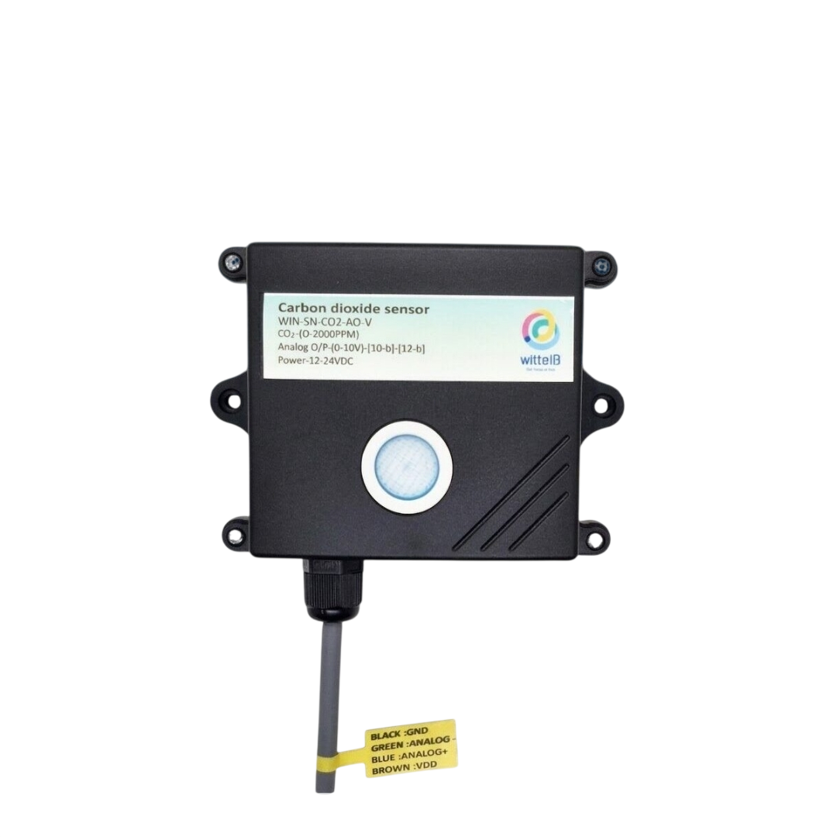
WIN-SN-A5S-MRTU-WiFi is a versatile data acquisition device designed for real-time monitoring in industrial applications, especially ducts. It supports a wide range of external sensors with UART interface, providing flexibility for various measurements. Offering reliable communication and long-range data transfer over several meters, making it ideal for large-scale installations.
Its robust design makes it suitable for installations in HVAC systems, environmental monitoring, and process control. With configurable data sampling rates, multi-sensor compatibility, and easy configuration, WIN-SN-A5S-MRTU-WiFi ensures accurate Sensor (CH4/H2S/CO2/CO/NH3/PH3) data acquisition and reliable performance in demanding industrial environments, making it an excellent choice for industrial and IOT applications. It supports multiple communication protocols, allowing users to select either RS485 (Modbus RTU) or Wi-Fi (MQTT) based on their application requirements, providing greater flexibility for industrial and IOT deployments. Additionally, it features a 4-digit 7-segment display that provides real-time measurement data, allowing users to monitor sensor readings directly without requiring an external interface.
Sensor Parameters
 | SN | Sensor Name | Measuring Parameter | Measuring Range | Output | Operating Temperature
☐ | a | A-5S-CO | CO | 0-1000 ppm | RTU /WiFi | -20°C to +50°C
☐ | b | A-5S-CO2 | CO2 | 0-5000/ 10000/ 40000 ppm | RTU /WiFi | -20°C to +50°C
☐ | c | A-5S-NH3 | NH3 | 0-100 ppm | RTU /WiFi | -20°C to +50°C
☐ | d | A-5S-PH3 | PH3 | 0-1000 ppm | RTU /WiFi | -20°C to +50°C
☐ | e | A-5S-CH4 | CH4 | 0-10000/ 20000 ppm | RTU /WiFi | -20°C to +50°C
☐ | f | A-5S-H2S | H2S | 0-100 ppm | RTU /WiFi | -20°C to +50°C

 | Product Configuration
☐ | A5S+M
☐ | A5S+M+D
☐ | A5S+W
☐ | A5S+W+D
☐ | A5S+MRTU+WiFi
☐ | A5S+MRTU+WiFi+D
2. Technical Parameters
- CO Sensor
- Target Gas: Carbon Monoxide(CO)
- Detection Range: 0 to 1000ppm
- Accuracy: ±1 ppm or ±1%
- Detection Accuracy: ~90%
- Technology: Non-Dispersive Infrared (NDIR)
- Response Time: Less than 3 seconds

- CO2 Sensor
- Target Gas: Carbon Dioxide (CO2)
- Detection Range: 0 to 5000/10000/40000 ppm
- Accuracy: ±1 ppm or ±1%
- Detection Accuracy: ~90%
- Technology: Non-Dispersive Infrared (NDIR)
- Response Time: Less than 3 seconds

- NH3 Sensor
- Target Gas: Ammonia (NH₃)
- Detection Range: 0 to 100ppm
- Accuracy: ±1 ppm or ±1%
- Detection Accuracy: ~90%
- Technology: Non-Dispersive Infrared (NDIR)
- Response Time: Less than 3 seconds

- PH3 Sensor
- Target Gas: Phosphine (PH₃)
- Detection Range: 0 to 1000ppm
- Accuracy: ±1 ppm or ±1%
- Detection Accuracy: ~90%
- Technology: Non-Dispersive Infrared (NDIR)
- Response Time: Less than 3 seconds

- CH4 Sensor
- Target Gas: Methane (CH4)
- Detection Range: 0 to 10000/20000 ppm
- Accuracy: ±50 ppm or ±1%
- Detection Accuracy: ~90%
- Technology: Non-Dispersive Infrared (NDIR)
- Response Time: Less than 3 seconds

- H2S Sensor
- Target Gas: Hydrogen Sulfide (H2S)
- Detection Range: 0 to 100 ppm
- Accuracy: ±1 ppm or ±1%
- Detection Accuracy: ~90%
- Technology: Non-Dispersive Infrared (NDIR)
- Response Time: Less than 3 seconds

Note: All sensors require a 90-second warm-up period after power-on to provide accurate measurements.

2. Sensor Specifications
- Wide temperature range: −40 °C to +125 °C
- Full humidity range: 0 % to 100 % RH
- Power supply DC: 12-24V@1A.
- Product dimension: 85*85*36 mm.

- Certifications:

3. Power Supply Connection
DC Connection
- Use 12-24V@ 1A, Power supply.
- Don’t make loose connection.
5. Recommended Cable Electrical Characteristics
22 AWG Cable Shielded and twisted pair should be used.
Tinned Copper Recommended
Nominal Conductor DCR 14.7 ohm / 1000 ft
Nominal Capacitance 11 pf / feet (conductor to conductor)
High Frequency Non-Insertion Loss 0.5db / 100ft

6. Device Configuration Process
- Connect the Device
  - Connect 12v-1A DC adaptor to power the board
  - Connect the Wi-Fi SSID: WittelB-SN-A5S Pass:123456789
  - Enter the IP 192.168.4.1 in web browser
  - Refer image 1 for Wi-Fi WittelB-SN-A5S
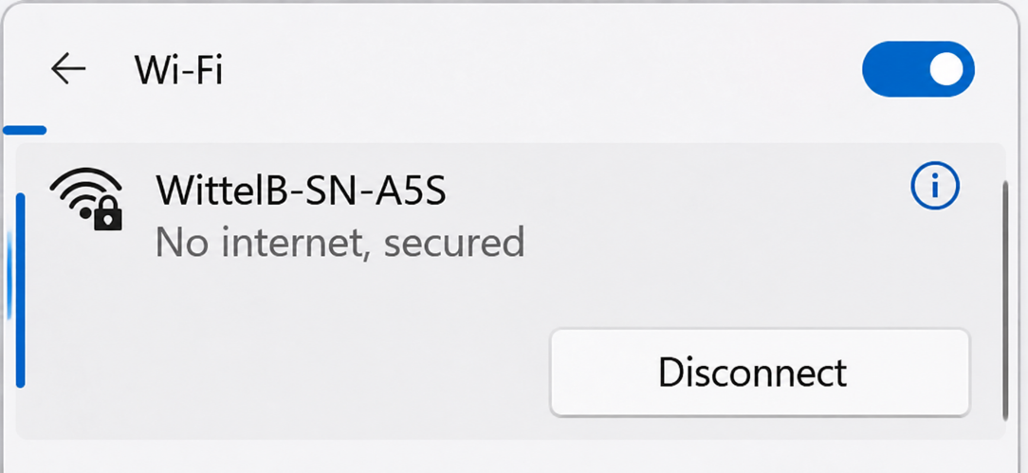

Image: 1

- Mode Selection
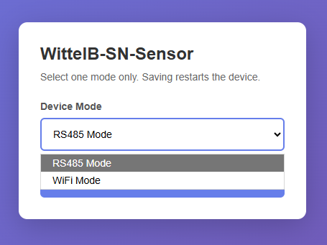

  - Enter 192.168.4.1 in the browser search bar and select the Device Mode.
  - Select the device mode as RS485 Mode to get the sensor data via Modbus RTU, or select WiFi Mode to get the sensor data in the MQTT cloud through the local WiFi network.

- RS485 Mode
Configuration Settings
- Communication Speed 9600 – 115200 Kbps (SW Selectable)
- Data Bits 8
- Parity None
- CRC Yes
- Slave ID 1, DIP (SW Selectable)
- Function Code 0X03 (Read Holding Register)

- Here is an example of receiving data on Mb poll software.
- Open Mb-poll software connect using configuration setting (Default baud rate is 9600 and slave id is 1).
- After connecting you will get data as shown below.
Important Note
- If you want to enter the baud rate 9600/19200/38400/57600/115200etc, enter it like this 960/1920/3840/5760/11520etc.
- After that press the reset button or reboot the system.
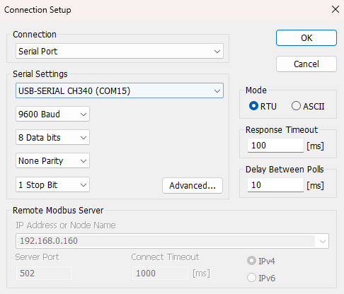
- Then you will get the present value of 11520 at 40011 baud rate (115200) and 2 at 40013 slave id.
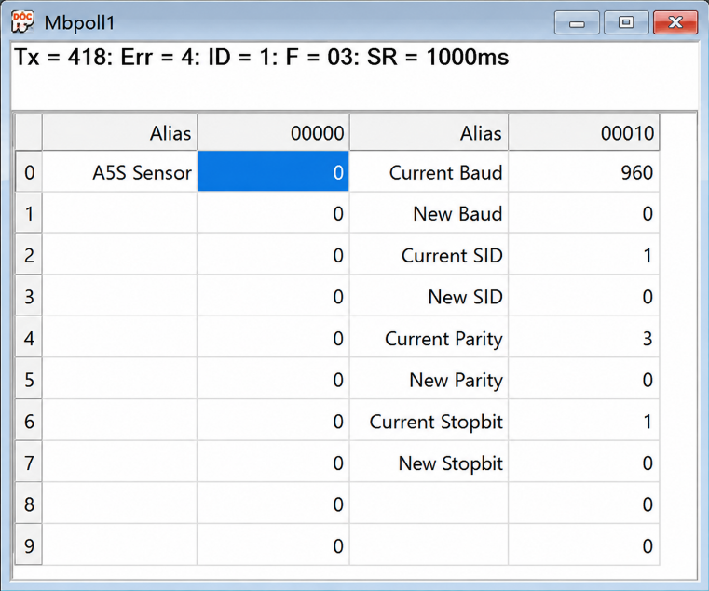
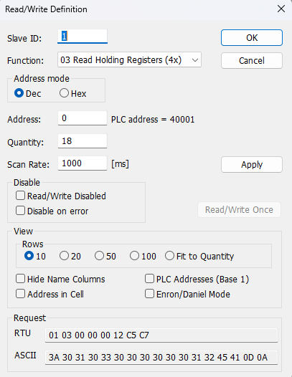

- Above image Shows sensor data over Modbus with default Modbus settings
- Register 40001 contains the measured gas concentration value corresponding to the connected sensor (CO/CO₂/NH₃/PH₃/H₂S/CH₄).
- As you can see in the image above, the resistor 40011 – 960 represents the present baud rate (9600) of the board and 40013 – 1 represents the present slave id of the board.
- To change the baud rate and slave id Jumper should be in single/removed then, you must enter a value on the 40012 resistors for the baud rate and 40014 for the slave id as shown in the image below and restart the board.
- Now you can see data below image set 115200 baud rate and slave ID 10.
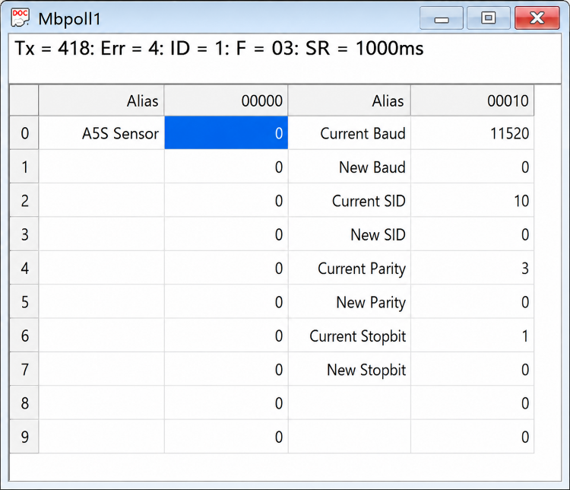
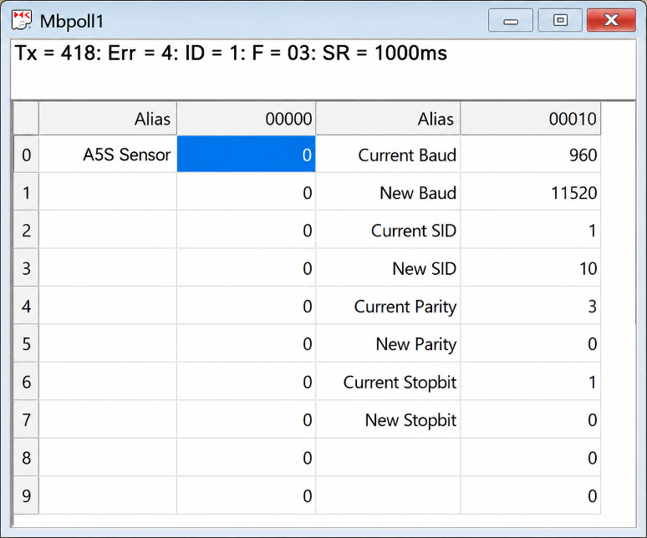

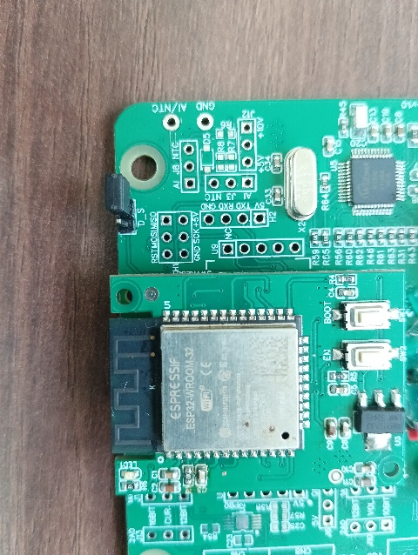
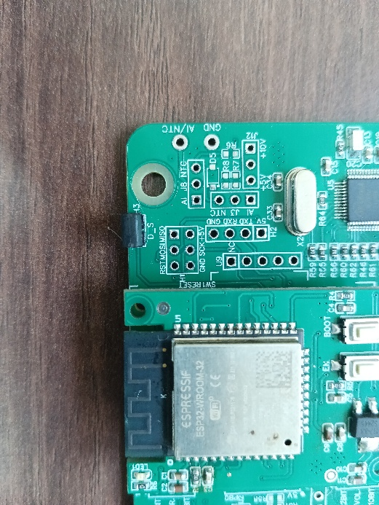

IP config JUMPER
RESET JUMPER

Image: 1.1 Image: 1.2

Hard reset Setting
- Somehow you forgot the baud rate or slave id of the board then Place the jumper (as shown in the above image 1.1) from the board reboot the system or press the reset button (given on the board). Then you will get the default baud rate of 9600 and slave id 1.
Modbus Registers Mapping
ID | Function  Description | Register  Description | Modbus Function Code | Protocol | Data Type
1 | A5S Values | 40001 | 0x03 | RS485 | 16-bit int
1 | Display Baud Rate (Default: 960) | 40011 | 0x03 | RS485 | 16-bit int
2 | Enter New Baud Rate | 40012 | 0x03 | RS485 | 16-bit int
3 | Display Slave ID (Default: 1) | 40013 | 0x03 | RS485 | 16-bit int
4 | Enter New Slave ID | 40014 | 0x03 | RS485 | 16-bit int
5 | Display Parity (Default: None-3 And for Odd-1, Even-2) | 40015 | 0x03 | RS485 | 16-bit int
6 | Enter New Parity | 40016 | 0x03 | RS485 | 16-bit int
7 | Display Stop Bit (start-2/stop bit-1) | 40017 | 0x03 | RS485 | 16-bit int
8 | Enter New Start/ Stop Bit | 40018 | 0x03 | RS485 | 16-bit int

- WIFI Mode
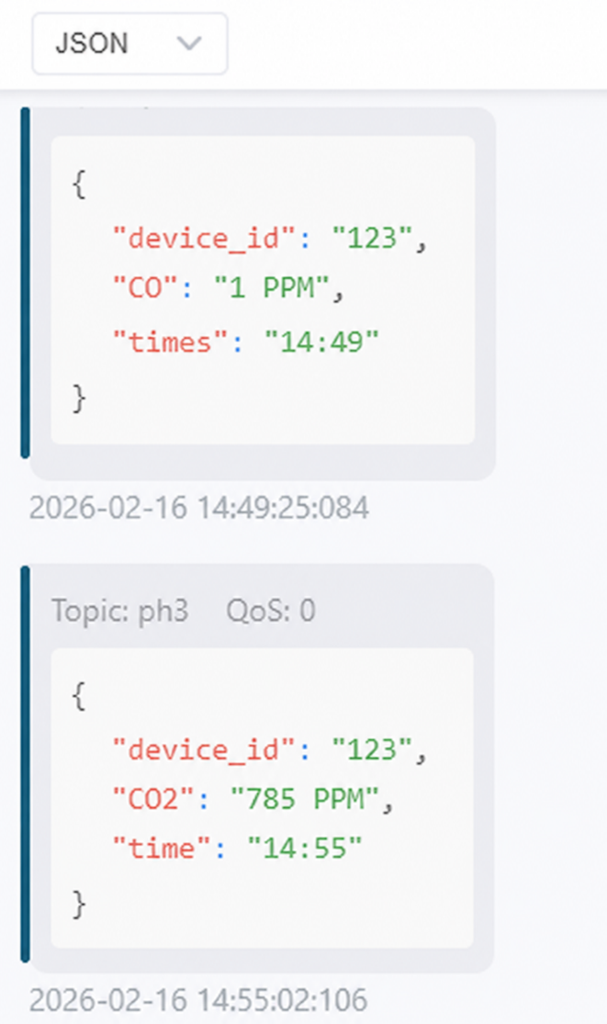
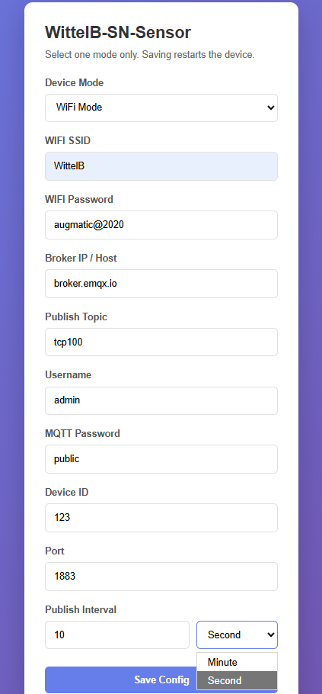

Image: 2 Image: 3
- Enter the local WiFi credentials as shown in above image2 so the device can connect to that WiFi network. Using this connection, it will send the sensor data to the cloud.
- Then enter the required MQTT Credentials and make sure the credentials should be correct.
- As shown in Image 2, you can select the publish interval in either minutes or seconds. MQTT data will be published according to the selected interval.
- Enter the MQTT credentials to transmit the sensor data to the cloud.
- Image 3 shows the sensor data at cloud for the selected topic.
- The published JSON payload includes a real-time timestamp, allowing each sensor reading to be tracked with its exact time.

Contact Information
Augmatic Technologies Pvt. Ltd.,
Plot no 6, Shah Industrial Estate II,
Kotambi,
Vadodara – 391510.
Email – Sales@wittelb.com
Support: support@wittelb.raiseaticket.com / +91 94038 92805

